Village of Williams Bay – Online Tax Payment Instructions
You will need to pay your property taxes through Walworth County’s Ascent Land Records. https://ascent.co.walworth.wi.us/LandRecords/PropertyListing/RealEstateTaxParcel#/Search

Step 1. Once you click on the link, you will need to find by parcel by selecting “Village of Williams Bay” as Municipality and searching by Parcel ID or Street Number (only the number) or Street Name (do not include St., Dr. etc.) or by First Name and/or Last Name. Do not try to enter a combination of any of these search options – only one subject should be searched:
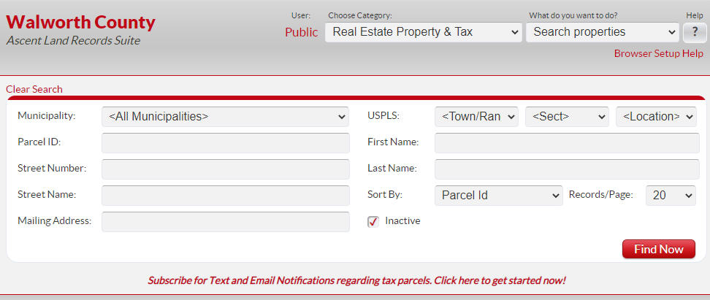

Example (Village of Williams Bay owned properties):

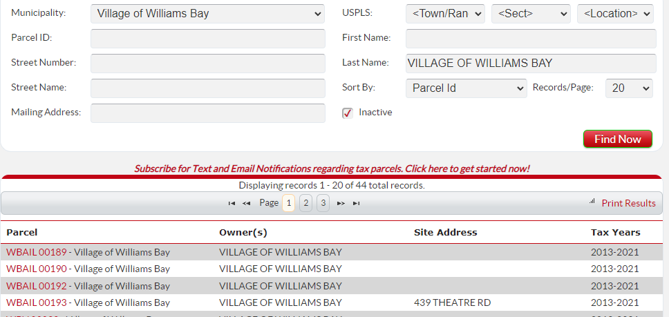
Step 2. Once you have found your property, click on the red parcel number (outlined above), a link to the property details:
Ensure in the Select Detail dropdown you select Taxes
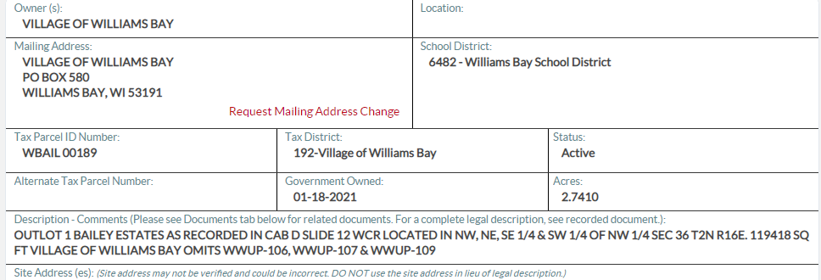

Step 3: The Tax History information will take a moment to load and then click Pay Taxes
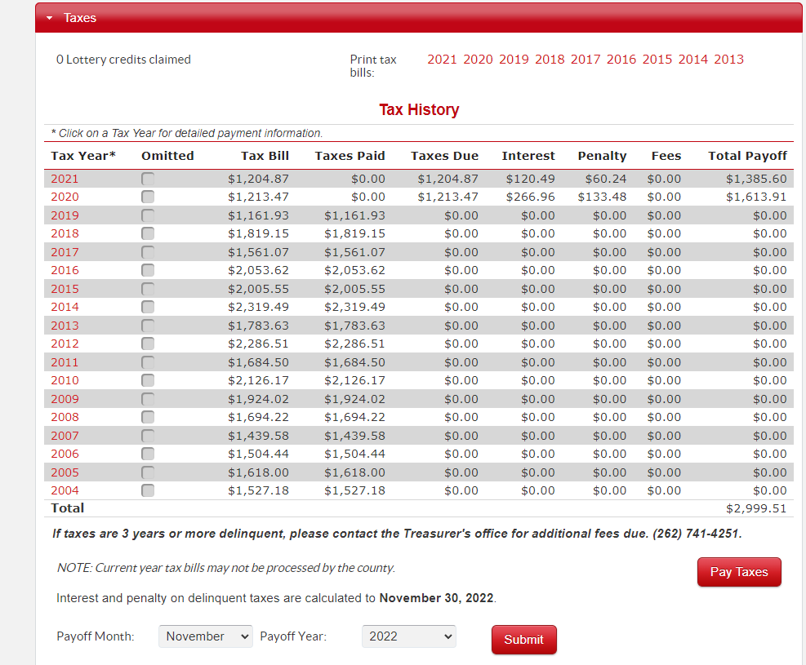

Step 4: The shopping cart will populate. If multiple parcels with the same mailing address are found, you can add them to the shopping cart by clicking the Add To Cart link.
You will also have the option to add additional parcels with different mailing addresses by clicking Add Additional Parcel(s) which will bring you back to Step 1.

Important: the shopping cart will generate the total amount due. If you wish to pay your first installment or a portion of your tax payment, then you must update here.
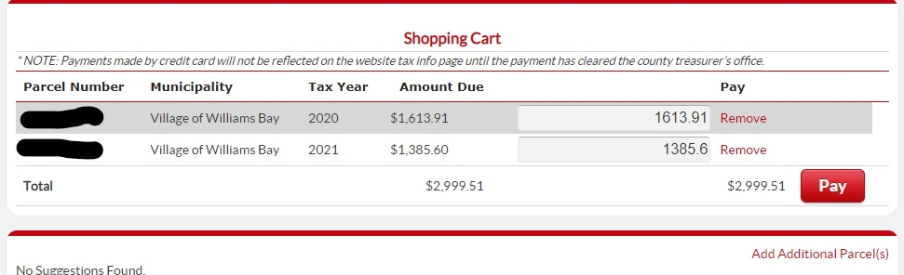

Step 5. Once you have all the parcels that you wish to add to your payment click Pay.

Step 6. A pop up will generate alerting you that you are leaving Walworth County’s website. Click OK to continue or Cancel to return to the shopping cart:
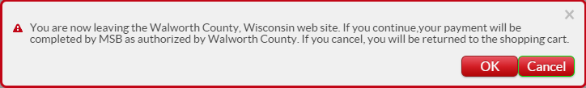

Step 7. Clicking OK will take you to an acceptance page that will inform you of the fees associated with making a payment online. Select a payment method and click Make Payment to continue:
NOTE: THE FEES LISTED BELOW ARE FOR EXAMPLE PURPOSES ONLY. ACTUAL FEES ARE AS FOLLOWS:
2.35% on the total amount due for Visa Credit/Debit, MasterCard Credit/Debit, American Express and Discover. ($15.00 chargeback for declined payments)
$0.50 for e-check. ($15.00 NSF Fee)

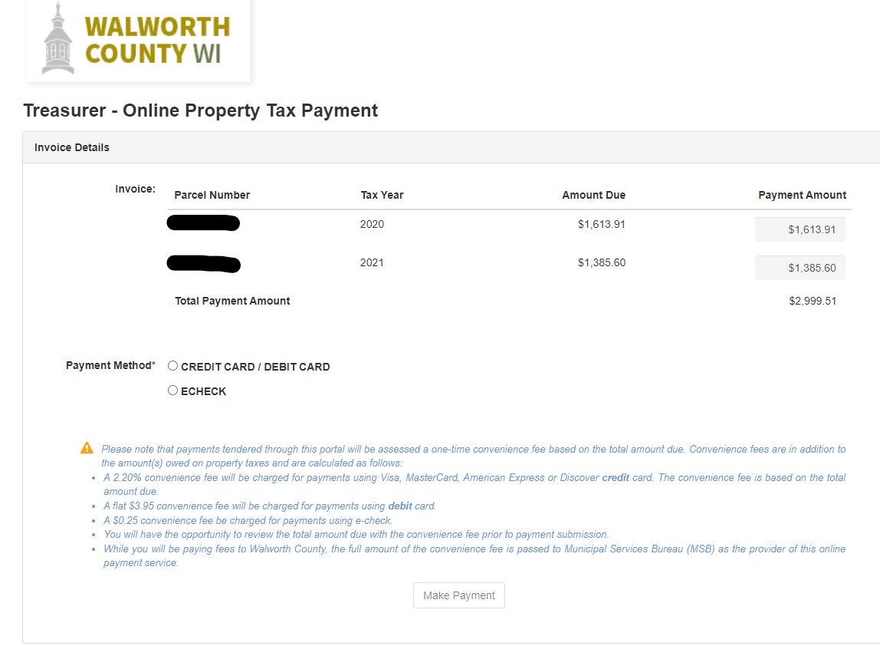
Step 8. Enter payor detail and click Submit Payment. The example below is for an E-Check payment:
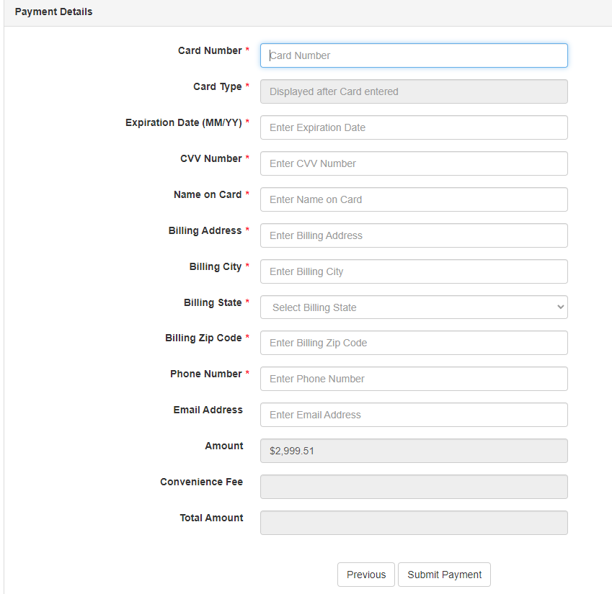

Step 9. Your pending receipt will open, and you can then download or print for your records. Your payment will be finalized in the next two business days.
After two business days, you can confirm by checking your Tax History (Step 3). Your payment amount will be reflected under Paid to Date.
If you would like an email copy of your official receipt, send your request to treasurer@vi.williamsbay.wi.gov

